REROUTE ADVISORY: Route #2 Ponce de Leon Ave / Druid Hills, #19 Clairmont Rd / Howard Ave, and #34 Gresham Rd
WHAT: Pedestrian Bridge Replacement at East Lake Station
WHERE: East Lake Station: 1171 W Howard Ave, Decatur, GA 30030
WHEN: Monday, March 9, 2026, through Monday, May 30, 2026
TIMES: From the Beginning until the End of the Revenue Service

Reroute as follows:
Inbound: Route #2 from North Avenue Station to East Lake Station
Continue East Lake Dr
(Begin Reroute)
Right – Paden Cir
Right – W. Howard Ave
Right – Into Bus Staging Area (EOL)

Outbound: Route #2 from East Lake Station to North Avenue Station
(Begin Reroute)
Continue right into the parking lot
Right – Last row in parking lot
Left – Paden Cir
Left – East Lake Dr
Regular route

Inbound: Route #19 from Chamblee Station to East Lake Station
Continue W. Howard Ave
(Begin Reroute)
Continue W. Howard Ave (Past Paden Circle)
Right – Into Bus Staging Area (EOL)

Outbound: Route #19 from East Lake Station to Chamblee Station
(Begin Reroute)
Continue right into the parking lot
Right – Last row in parking lot
Right – Paden Cir
Left – W. Howard Ave
Regular route

Inbound: Route #34 from Georgia Perimeter College to East Lake Station
Continue East Lake Dr
(Begin Reroute)
Continue East Lake Dr (Past Park Pl)
Left – Paden Cir
Right – W. Howard Ave
Right – into the parking lot
Immediate Right into the First Row of the Parking Lot (Proceed to the Marked location EOL)

Outbound: Route #34 from East Lake Station to Georgia Perimeter College
(Begin Reroute)
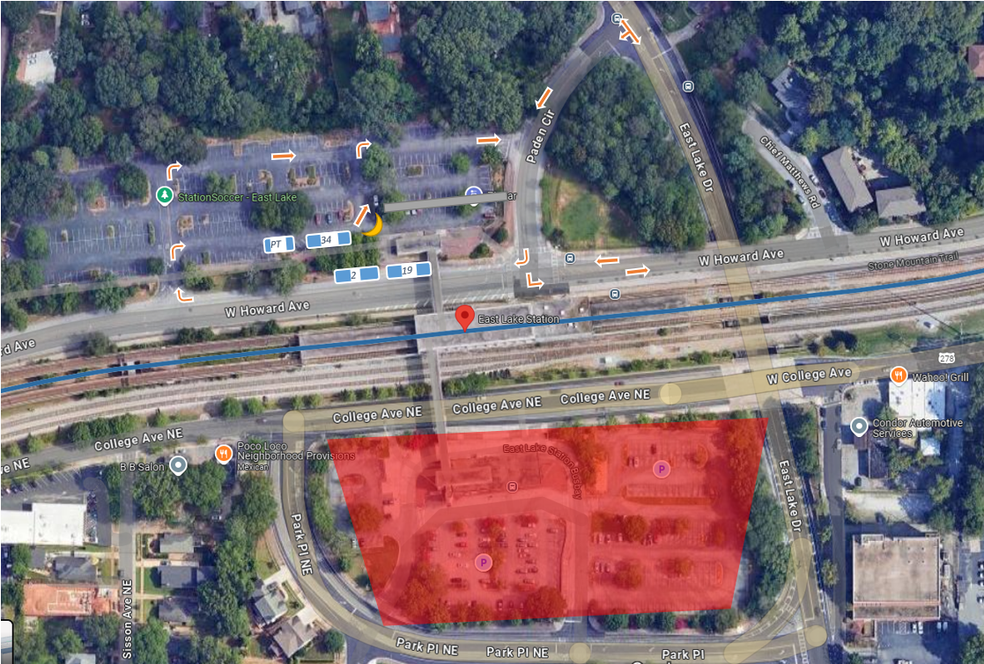
Immediately left to the last row in the parking lot
Right – Last row in parking lot
Left – Paden Cir
Right – East Lake Dr
Regular route

